**OUTREACH SCHOOLS EXAMINATION BOARD**

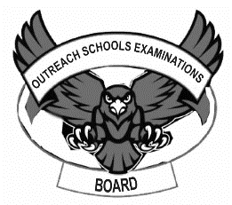 **END OF TERM II EXAMINATION 2024**

**MIDDLE CLASS: (4 – 5 YEARS)**

**LEARNING AREA 1: SOCIAL DEVELOPMENT**

**My name is: ………………………………..………………………….**

**My School is: ……………………………..……….…………………..**

**I am in: ………………………………..…………………………………………..**

1. **Oral.**
2. **What is the name of your school?**
3. **What is the name of the head teacher?**
4. **How many days make up a week?**
5. **How many months make up a year?**
6. **Why do we come to school?**
7. **Name these people.**

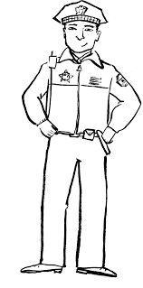 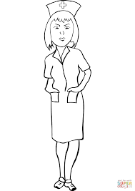 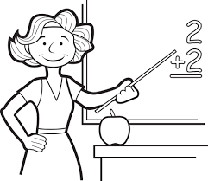

1. **What are the things we use to clean our environment?**
2. **Match pictures to words.**

apple

box



bag

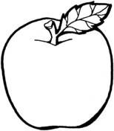

jug



 ball

hoe

1. **Match correctly.**

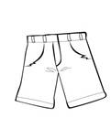

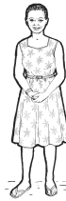



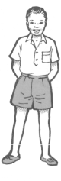

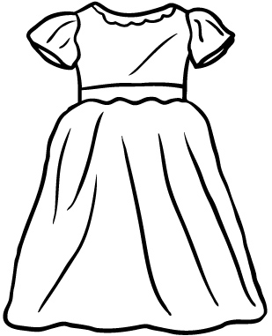

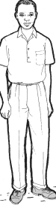

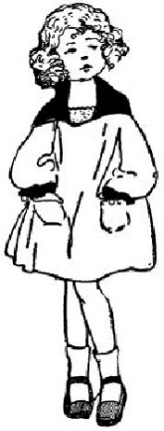

1. **Name the pictures.**

pot



**doll**

**mat**

**pot**

**boy**

**cup**

___________

____________



_____________

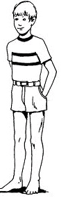

______________

**END**